

HCP – List Report

**SUBMIT A WORD DOCUMENT CONTAINING SEVEN (7) SCREENSHOTS SHOWING YOUR PROGRESS THROUGH THE ASSIGNMENT.**

**Product**

HANA Cloud Platform

**Level** Undergraduate/Graduate Beginner

**Focus**

HANA Cloud Platform

**Author**

Ross Hightower

**Revised by**

Elizabeth Simmons

**MOTIVATION**

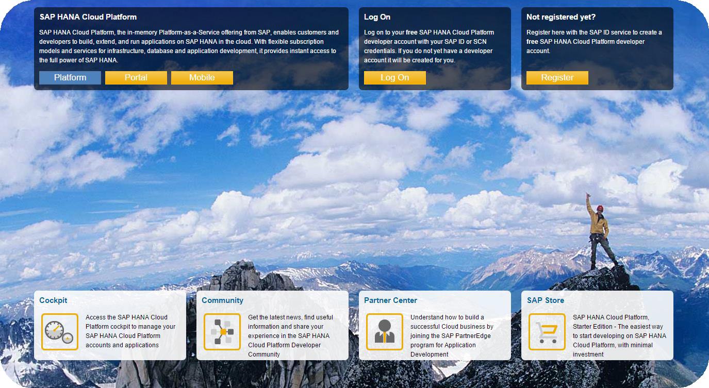

This case illustrates list report for creating

Fiori applications.

**PREREQUISITES**

01 HCP – Register for HANA Developer Accounts

**List Report**

List report use annotations to create an application. The annotations can be embedded in an OData service or in a separate file. This allows the service developer to determine how the data should be demonstrated and improves the efficiency of application development because many of the fundamental design decisions and code development are handled automatically. An added benefit is that standards are enforced across different applications for similar types of data types.

**Create the Application**

This case assumes you completed the first case in which you created accounts for HCP and the Netweaver Gateway and created a destination to the NetWeaver Gateway. If you haven’t completed that case, complete it before continuing.

**Logon to the Web IDE** and create a new project from a template either by clicking the icon, or you can invoke the wizard by using the File menu to select **New → Project from Template**. **Make sure to select SAPUI5 Version as 1.38**.

Select the **List Report Application** template and click **Next.**

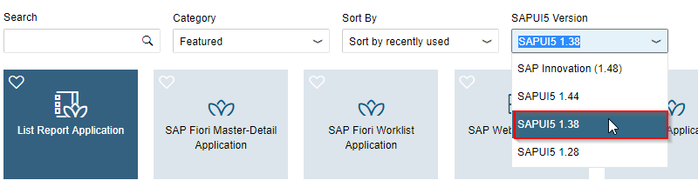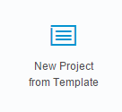

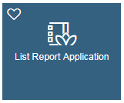

Enter **Sales_Orders** for the P**roject Name** and **Sales Orders by {YourName}** for the **Title,** then click **Next**.

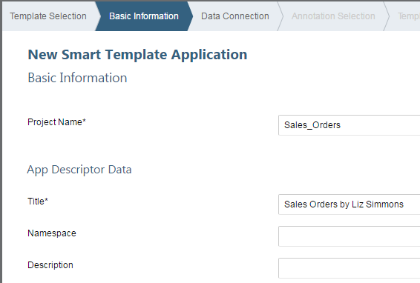

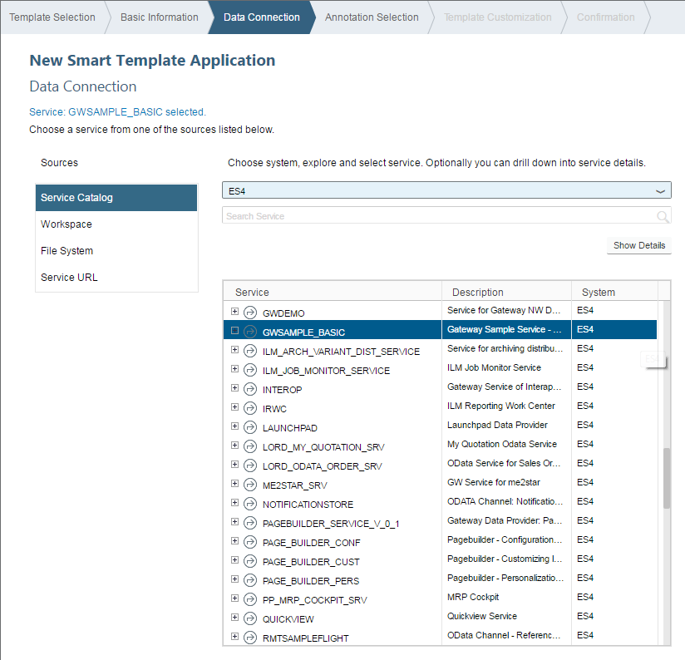Choose the **NetWeaver Gateway (ES4)** destination in the Service Information dropdown, and then search for the **GWSAMPLE_BASIC** service using the search input box. Select the service and click Next.

The annotations are included in a separate file for this case. Click **+Add Annotation Files** then select **File System**.

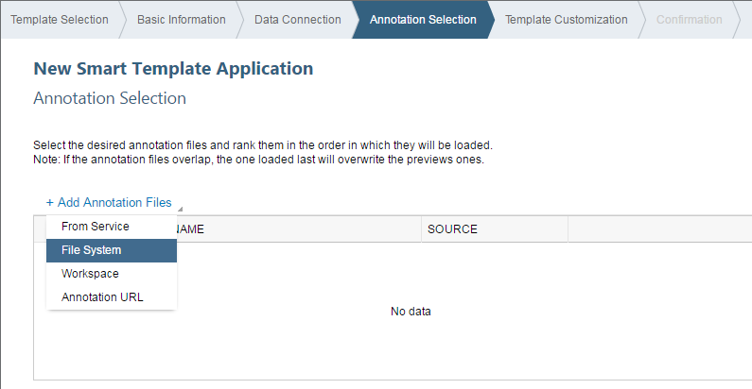

Select the **SmartTemplate_BASIC_0_annotations.xml** file (download from Blackboard) and click **OK**.

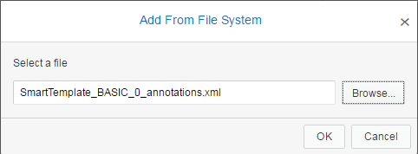

Once the file is parsed, the screen should look like the image below. Click **Next**.

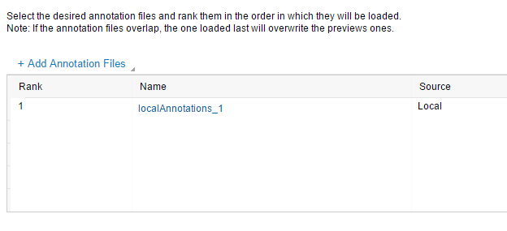

Select **ProductSet for OData Collection;** the only option for **OData Navigation** will be entered by default. Click **Finish.**

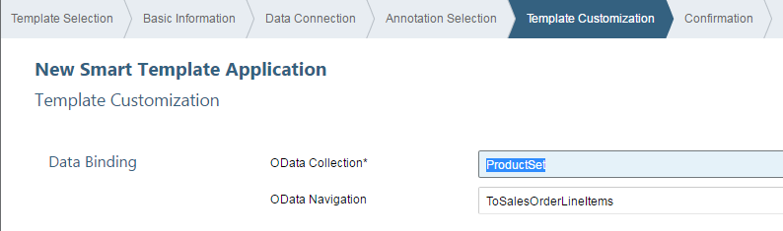

Your project is created and displays in your Web IDE workspace.

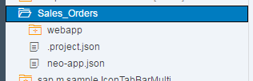

Right-click your project folder and click **Run → Run Configurations.**

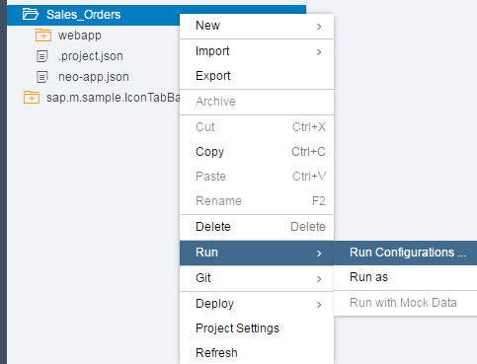

Click the **plus sign** to create a new Run Configuration. Select **SAP Fiori Component on Sandbox.**

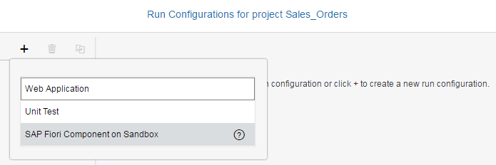

If not set by default, select **/webapp/Component.js** for the **File Name,** then select **Without Frame** as your Preview Mode. Click **Save and Run.**

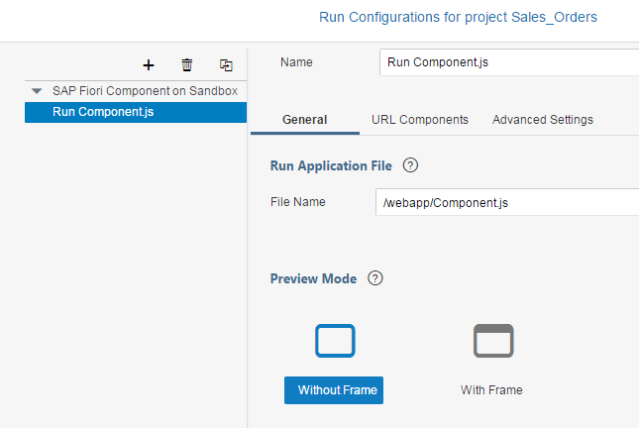

Initially there is no data displayed because no fields have been specified.

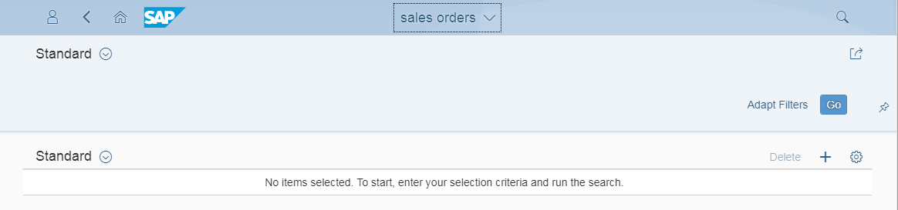

**SS1: TAKE A SCREENSHOT OF YOUR RESULT PAGE AND PASTE IT INTO YOUR WORD DOCUMENT**

The customizability of SAPUI5 is illustrated by clicking the gear icon  on the first view.

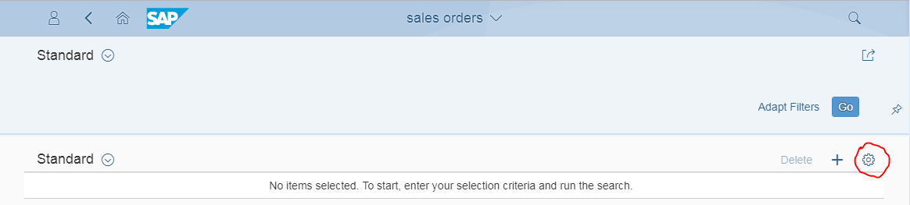

This opens a **Settings** dialog box that allows you to select columns to display, add a Sort, add Filters, and add grouping to the data. **Select some relevant fields, click OK. Then click the Go button to retrieve the data**. These settings are only available for this session, and the page will not keep your choices if you close the page. You will configure the page to show specific data in the next steps.

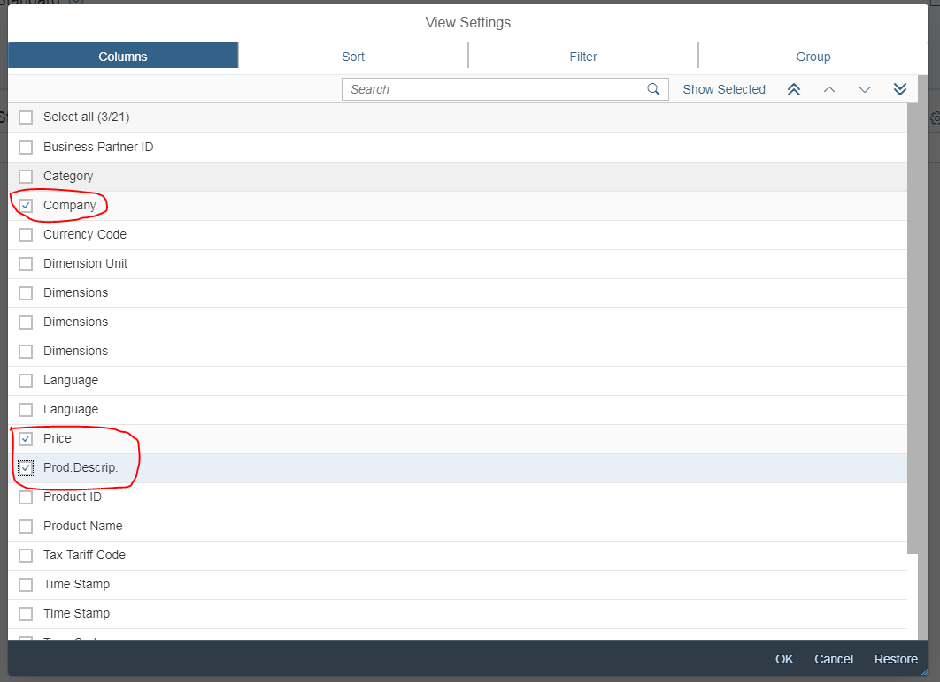

**SS2: TAKE A SCREENSHOT OF THE DATA FIELDS THAT YOU HAVE SELECTED AND PASTE IT IN THE WORD DOCUMENT.**

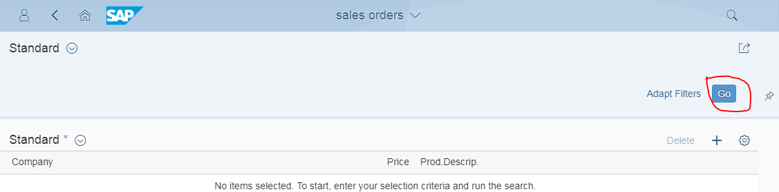Click the Go button to retrieve the data

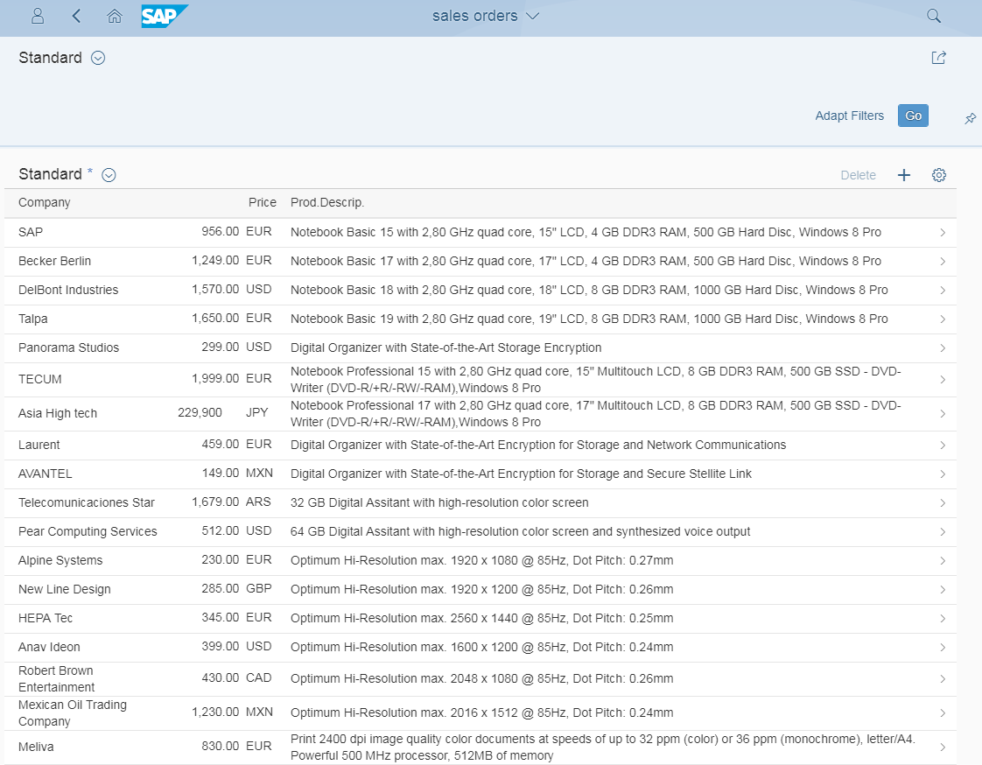

**SS3: TAKE A SCREENSHOT OF YOUR RESULT PAGE WITH YOUR SELECTED DATA FIELDS AND PASTE IT INTO YOUR WORD DOCUMENT.**

**Configure the First View**

In the Web IDE, expand the project to locate the **localAnnotations_1.xml** file.

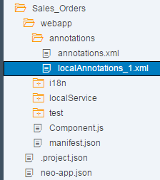

Right-click the file and select **Open With → Annotation Modeler**.

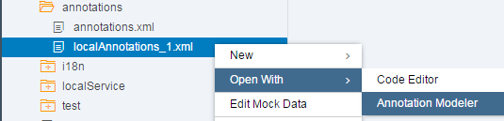

Click the **plus sign** next to **Annotations (under Local Annotations)**.

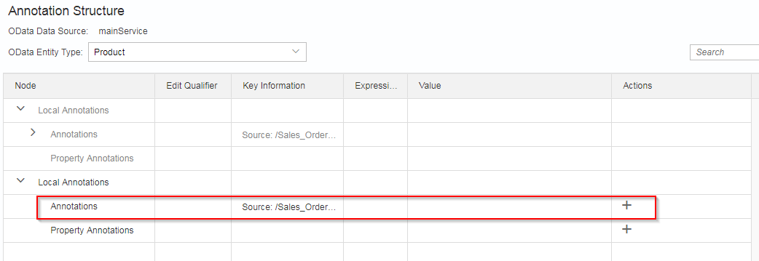

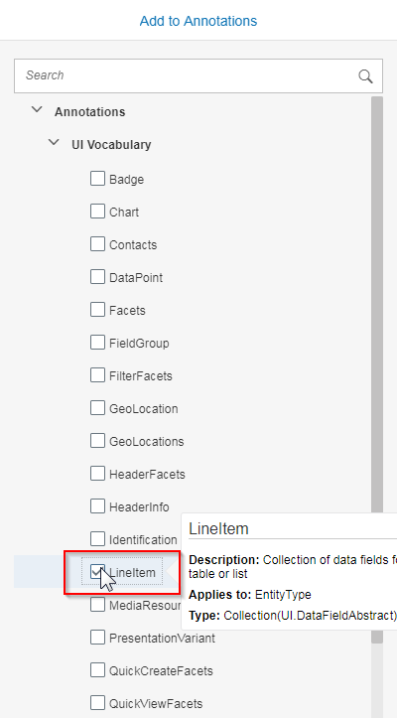The Local Annotations dialog box will open. Select **LineItem** and click **OK**. This item represents the fields in the table on the first view.

**Click the plus sign** **on the same row as the UI. LineItem**. Select **DataField** and click **OK.**

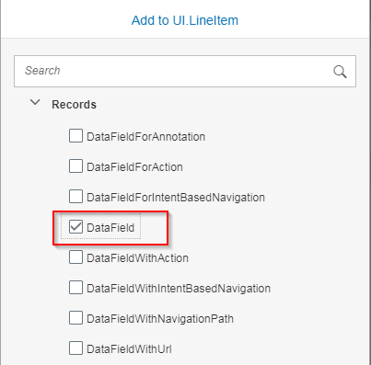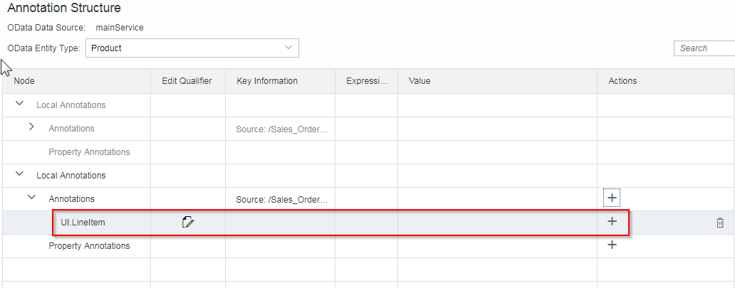

Under the newly created UI.DataField.

Select **ProductID** for the Value property.

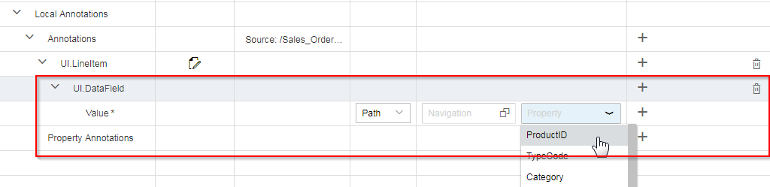

Add a second DataField to the UI.LineItem node with value **Name.** Your UI.LineItem DataFields should now look like those shown below:

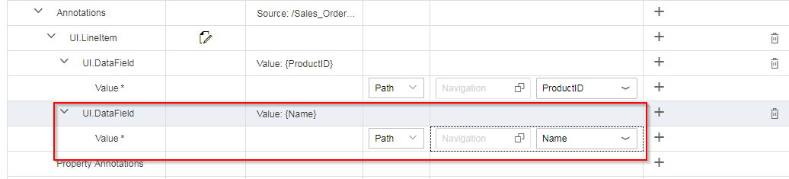

Save your changes by clicking .

Run  or refresh the application.

Click **Go** to load data.



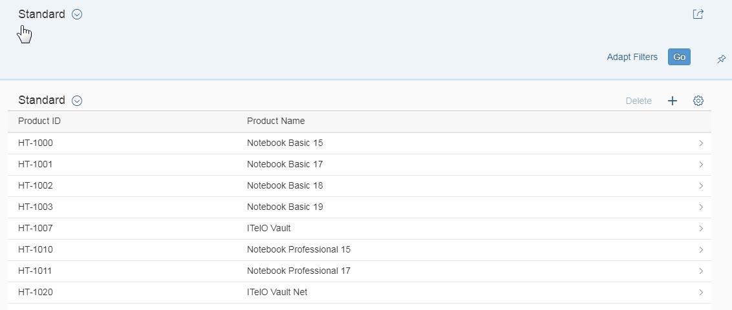

Return to the Web IDE and **click the plus sign on the row with Annotations** **(under Local Annotations)** to add an **Identification**.

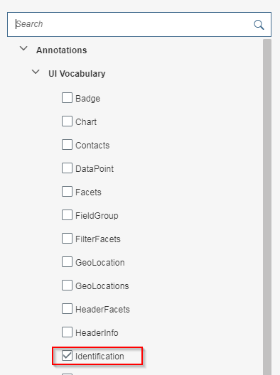

Add three **DataFields** to the **UI.Identification** with **Description,** **SupplierName** and **Price** as the property values.

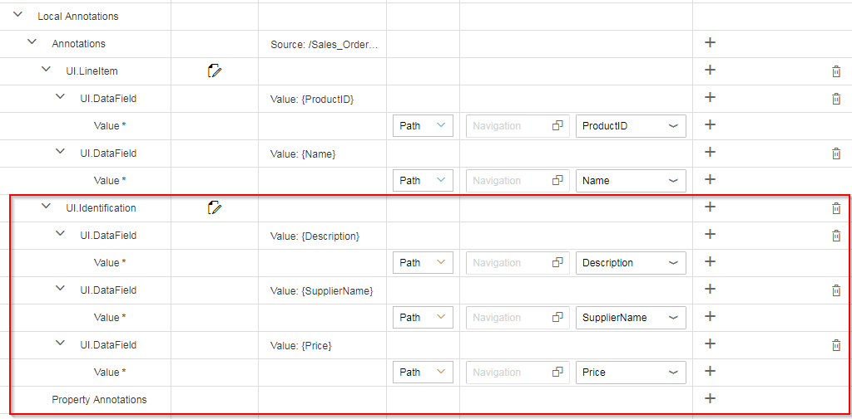

**Save and Run or refresh your application**. When you click a Product, the application will now navigate to a Details page where the new fields are shown. (Ignore any warning messages.)

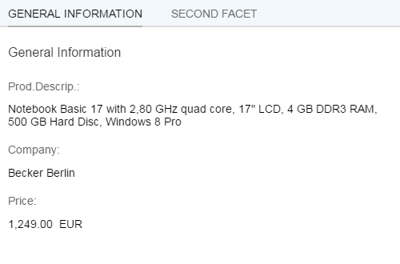

**SS4: TAKE A SCREENSHOT OF YOUR RESULT PAGE AND PASTE IT INTO YOUR WORD DOCUMENT.**

**Configure the Second View**

In the WebIDE, click the Select Targets button.

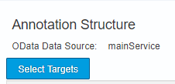

Select the **SalesOrderLineItem** collection

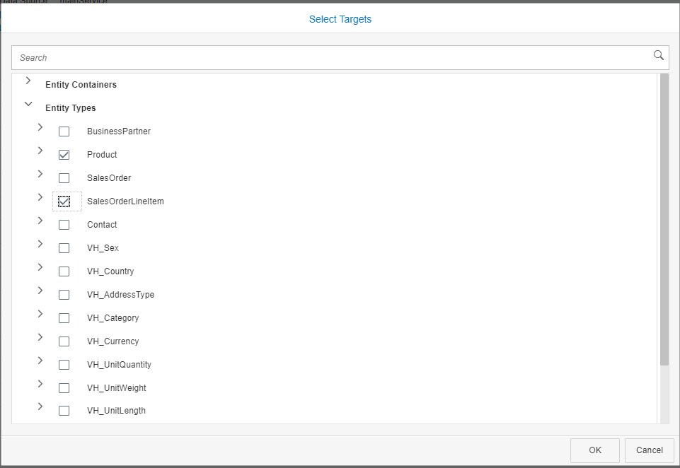

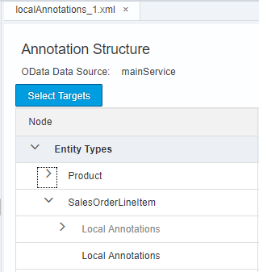

**Add a LineItem to the Local Annotations.**

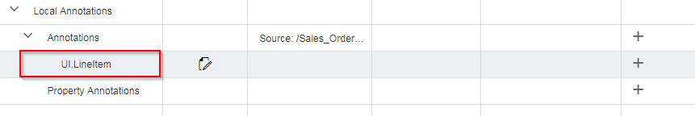

Add a **UI**.**DataField** to the **UI.LineItem** with **SalesOrderID** as the property value:

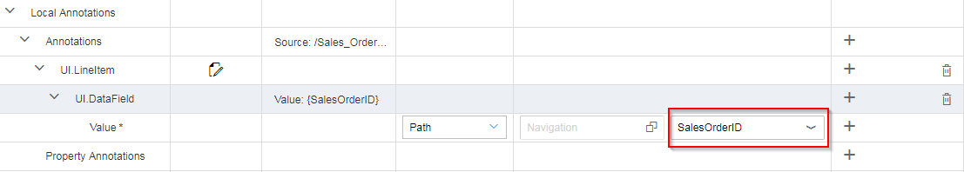

**Save your project and Run or Refresh the application**. Remember to click **Go** to load your data.

You can now click a Product on the first view, and the second view is loaded with product details, with the Second Facet information displayed below. Clicking the SECOND FACET tab shows only the SalesOrderID.

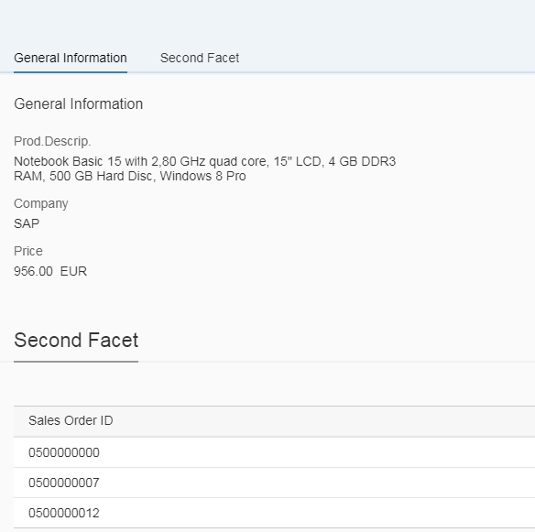

**SS5: TAKE A SCREENSHOT OF THE SECOND VIEW AND PASTE THEM INTO YOUR WORD DOCUMENT.**

**Add an Identification** **to the Local Annotations.**

Add a **DataField** to the **UI.Identification** with **Note** as the property value:

**SS6: TAKE A SCREENSHOT OF THE THIRD VIEW AND PASTE THEM INTO YOUR WORD DOCUMENT.**

Return to the first view of your application and click the **Settings** gear in the upper right corner to open the Settings dialog box. Select the following items:

|  |  |
| --- | --- |
| Columns: | Company  Price  Prod.Descrip |
| Sort: | Price > Descending |
| Group: | Category |

Click **OK.** Your screen will change to show your new customization Settings**.**

**SS7: TAKE A SCREENSHOT SHOWING YOUR CUSTOMIZED PAGE VIEW AND PASTE IT INTO YOUR WORD DOCUMENT.**

**SUBMIT YOUR DOCUMENT AS DIRECTED BY YOUR INSTRUCTOR.**